What Impact Does Gasoline Taxes have on Prices and Sales of Gasoline?

Caitie Schrotberger
Bellevue University
630 Predictive Analytics
Andrew Hua
November 21, 2025

What Impact Does Gasoline Taxes have on Prices and Sales of Gasoline?
As the adage goes, the only thing certain in life is death and taxes. In today’s culture where social media and news television provide real-time information on what is occurring in the world, every little change is broadcast everywhere for anyone to speak or have an opinion on. Gasoline is one of the things this country relies heavily on for transportation. According to the U.S. Energy Information Administration, 17% of the price of a gallon of gasoline is taxes. The remaining is crude oil, refining, and distribution. On the current average retail price of $3.13 per gallon across the country, that 17% equates to $0.53.
This project will evaluate how taxes on gasoline impact the price and sales of gasoline. One would assume as taxes go up, so should the price – which may lead to decreased sales. There may be other factors such as crude oil prices, weather conditions, geopolitical events, but this data analytics project will see if this is true and if so to what degree taxes influence the consumer cost and volume of gasoline sold. This type of model could benefit consumers, politicians, oil companies, gasoline distributors, and retail gasoline facilities. People can plan their business or travel based on the predicted price from tax changes.

Data Selection
For this project I have selected four public datasets as provided by federal entities. The first two are from the U.S Department of Transportation Bureau of Transportation Statistics. The first is “Tax Rates by Motor Fuel and State”. The data set has 11 columns and 2332 rows containing annual data from 2013-2023. It provides the Federal tax rate and the States rates by fuel type. The variables include a unique id, state, tax rate (in a whole number), fuel type, state abbreviation, and the year the tax rate was effective. There is also a free form note field for comments regarding the tax rate.
The second is “Monthly Motor Fuel Sales Reported by States: Selected Data from FHWA Monthly Motor Fuel Report”. This data set has 8 columns and 15, 252 rows. It provides US and state volume of fuel sales per gallon by month from 2023 through 2023. The variables include a unique id, state, state abbreviation, month, and value (gallons sold).
The third is from the U.S Energy Information Administration and called “Weekly Retail Gasoline and Diesel Prices”. It has data by Country, region, selected States, and selected cities. The key data element is the price per gallon. The spreadsheet contains 4 data sets. The first is for all US, second for regions (like east coast, central Atlantic, etc.), the third is for selected states such as California, Colorado, New York for a total of 9 states), and the fourth is for 10 major cities within those states (such as San Francisco, Denver, and New York City). Data sets one and two have data back until April 1993, while sets three and four start in May 2000. All sets have data through September 15, 2025. The data is updated weekly on Mondays.
The fourth is from the Federal Reserve Economic Data (FRED) sourced and maintained by the Research Department at the Federal Reserve bank of St Louis. The metric is the Gross Domestic Product (GDP) which is a weighted average of Economic Policy Uncertainty for 20 countries (Baker, 1997). The GDP is produced at many date dimensions, and this one pulls monthly data for the metric. Data is available from 1997 up to current.

Planned Learnings
In evaluating this data, I would like to learn how much taxes impact the retail sales price of gasoline. Crude oil costs are just over 50% of the price per gallon. If taxes become a larger percentage of the total does that change consumer behavior to not purchase as much gasoline or do they change their driving habits. Also looking at how taxes impact price can potentially show how the price of crude oil changes or how state and local entities change their tax rate to compensate for the federal tax changes.
There are many ways these three data sets (tax rate, sales price, and sales volume) could be evaluated among each other and by themselves even. The more difficult part of this for me will be to focus on one or two questions and not get lost in the data. Since all the data sets have multiple regions and state options, I’m going to choose to focus on the California data. Since the Federal tax rate has been stable since 1993.

Risks and Ethical Implications
As the data is released by federal entities, trust in the data is high. If the data sets were coming from a private source or gathered by AI there could be risks in using the data as the quality would be in question. Additionally other risks could be the data not showing a correlation, state specific regulations, and economic conditions. For ethical implications, taxes can be a controversial topic, especially in the political world. As this analysis is completed and presented it must be done so with no political bias.

Contingency Plan
The goal of this project is to analyze the impact of gasoline consumption and prices based on taxes. Having done some additional research on what drives gasoline prices there are other factors to consider. Oil inventory, refinery production, and government policy (Rhinehard, 2024) can influence price as well. Even weather and military action can (Mordowanec, 2025) can cause prices to go up or down. Based on this I’ve decided to include the montly Gross Domestic Product (GDP) (Baker, 1997) to the data I have available for analysis.
In the case that my plan does not show relationships or the data sets identified are not sufficient, I will do the following. The first would be to find different data sets with the same goal to see if the data I did find was not of quality. Options might be data sets that could be considered are crude oil production and socio-economic factors such as unemployment, consumer confidence, consumer spending, inflation, currency rates, population changes, and political changes. These could be used to expand upon the model if needed.
The second would be to adjust my problem statement. Maybe just to look at the tax rates or the retail price to see if I could create a prediction model based on historical values. Looking at a single data set would still allow me to use the same model and evaluation methods as the target is variable and not categorical. Additionally, I could look at other states or regions if the California data either doesn’t make a good model or does not show relationships.

Data Models and Evaluation Plan
Based on the data I have chosen the best model type for analysis will be regression. I will be using linear regression and possibly Ridge or Lasso regression. These types of regression models are good at looking at continuous rather than categorical based results. The goal is to find the best model that uses the best variables and reduces overfitting.
To evaluate the models, I will use Root Mean Square Error (RMSE), R-squared (R²), and the F-Test of overall significance. These tests evaluate the deviation of the data from the regression line, variation in the model for fit, and if it is statistically significant. Additionally, to make sure the model will apply to future data cross-validation will also be done.

Data Preparation
To prepare the data I download csv files from the cited sources. From there I looked at them in excel to familiarize myself with how the data was structure and formatted. There were two major observations to the data overall. First, they had different start and end periods. Secondly, I discovered that the gasoline tax rate actually does not change as frequently as I thought it did. The Federal tax rate has been stable since 1993 and state level tax rates change annually at most. To speed the combination of the data sets and make sure that the data was synced with the right time period I did so in excel. This also allowed me to apply the tax rate across the right yearly periods. The data was only available for the federal level and some major US states. The rest was regionalized. I decided to use California as the state for analysis. I then saved the data for California back to a csv for use within Jupyter.
After the data was imported into Jupyter for Python coding, I did a little more cleaning whereby removing the ID and State name, reordering the fields, and changing the format of the gallons sold field to float from object. All elements were graphed over time.

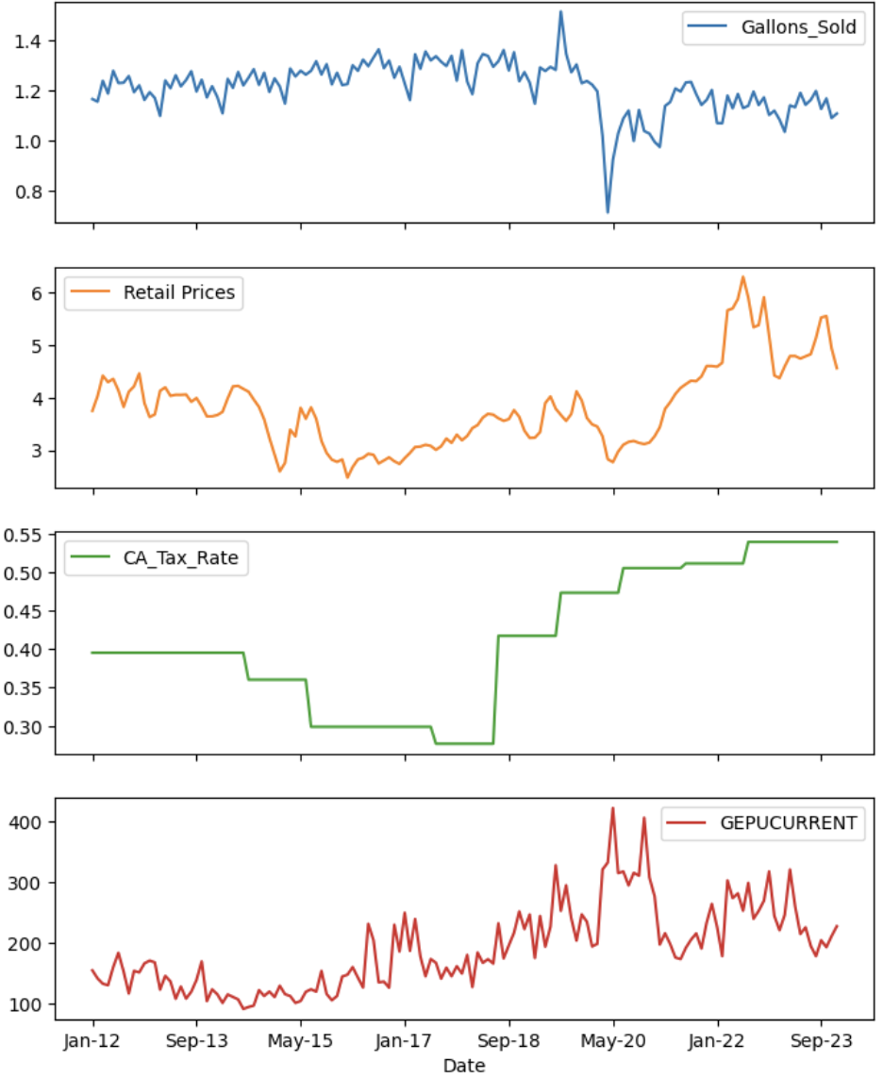

Model Building and Evaluation
I started my analysis looking at the impact of price, gallons sold, and GDP influencing on predicting tax rate. After looking at a correlation matrix, I used linear regression, Ridge, Lasso, and Random Forests models. I ran the R^2 and RMSE on all of them. Additionally, a normalized feature importance comparison was done.
 | Gallons_Sold | Retail Prices | CA_Tax_Rate | GDP
Gallons_Sold | 1.000000 | -0.219050 | -0.593143 | -0.479213
Retail Prices | -0.219050 | 1.000000 | 0.666901 | 0.186847
CA_Tax_Rate | -0.593143 | 0.666901 | 1.000000 | 0.597674
GDP | -0.479213 | 0.186847 | 0.597674 | 1.000000
This table shows the results of the correlation matrix. The California tax rate has a negative impact on the number of gallons sold, a positive impact on the retail price, and a positive relationship to the GDP.

These graphs show the difference in the model R^2 and RMSE results. When the R^2 is closer to 1 the model is a better fit to the date. The desired RMSE is closer to zero.
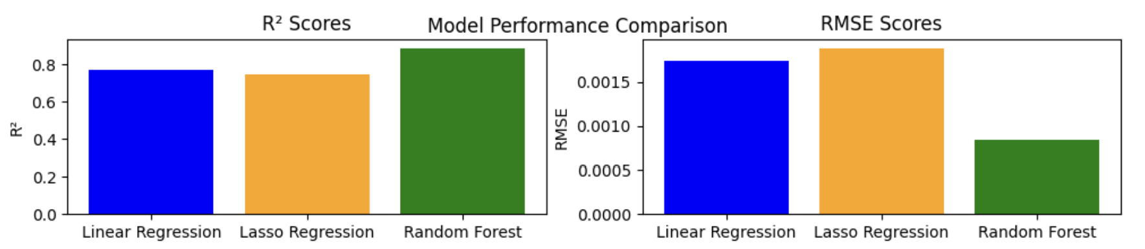
After looking at the results of these, I decided to go back and rerun the same models but where prices were the target and only taxes is the only feature. This would better answer the question: “What impact does gasoline taxes have on prices and sales of gasoline”.
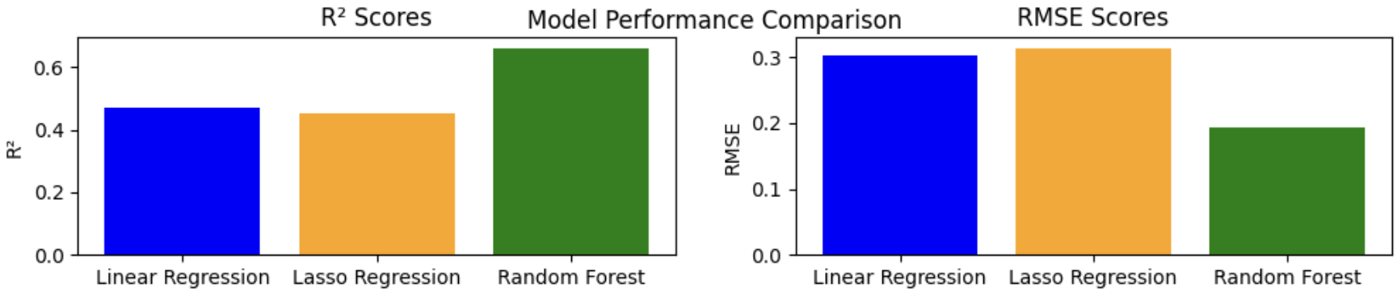

Interpretation
My initial plan was to use linear regression and possibly Ridge or Lasso regression for the models. As I started running the models I realized that the opportunity to run additional models may help the analysis. That is where adding a classification model, random forests, to my list.
When looking at the first model run where to determine which feature has the most impact on the tax rate, the correlation matrix had some impressive results. Retail prices had a 0.67 correlation with the tax rate, which makes sense. As the tax price goes up so should the retail price. GDP also influenced the tax rate positively (0.60) and the number of gallons sold negatively (-0.48). When GDP increases, the economy grows, and on the inverse the economy is struggling and may even be in a recession. It’s interesting then that a higher GDP would cause a decrease in the volume of gallons sold. It does make sense that the tax rate would increase as GDP does. The correlation between GDP and the retail price itself was 0.19, which is smaller than I would have predicted without looking at the data.
The different models generally work better with diverse types of data. Linear regression is great for a baseline model. Ridge and lasso models manage multicollinearity better. Whereas random forests is a flexible non-linear model.
Running linear regression, ridge, and lasso models all held comparable results with R^2 of 0.7689, 0.7688, and 0.7495 respectively and RMSE values close to zero (0.0017 for linear regression and 0.0019 for lasso). R^2 is a value from 0-1 with a higher value indicating good fit. RMSE is close to zero indicating that there is very little variance in the model with the potential for tax rate to only be off by pennies. Most interestingly was the random forest model that provided a R^2 of 0.8892 and an RMSE of 0.0008 indicating an even better model fit. The normalized feature importance shows that retail price is the most important feature for linear regression and lasso models, but GDP is the most important for random forests. The 5-fold cross validation on the R^2 score from the random forest results shows that the model is not consistent across the folds and may be sensitive and potentially unstable. The negative mean R^2 indicates poor model fit.
Running the same model processes with trying to predict retail price solely based on the tax rate showed the following: R^2 for linear, ridge, lasso and random forests as 0.4722, 0.3406, 0.3141, and 0.6615 respectfully with RMSE of 0.3023, 0.4516, 0.1940 for linear, lasso, and random forests. The feature importance showed that the tax rate was not important at all. And when comparing the models, this version shows that random forest was the best in model performance and minimizing variability. I provided an image of one of the forests used in the random forest for this situation and there were several tax rate cuts that broke down the data set, with the first being the tax rate under 0.508. The 5-fold cross-validation ran on the R^2 score was just as variable as the first random forest model with increased data sensitivity and poor fit.
All code and graphics will be provided in the Appendix.

Conclusion
Based on these model results I know there are relationships between taxes and the other features. Using the retail price, gallons sold, and GDP can predict the tax rate. When just looking at the tax rate alone and its ability to predict the retail price, the models are not as strong. This means that there are multiple variables that go into predicting the tax rate and price and using just one will not produce a strong model. My initial proposal was that as taxes go up so should the retail price leading to decreased sales. The models have shown that they could predict the retail price based on taxes but which much variance. This tells me that the other features are needed to accurately predict retail prices and volume of gasoline sold.
To be able to deploy a model for this topic, additional models would need to be run that include additional factors and look at different geolocations. I would start with one of the regions, then look to add some of the other data sets mentioned in the contingency plan section, hoping to find a stronger correlation in variables.

References
Bureau of Transportation Statistics. (2025, August 21). Monthly Motor Fuel Sales Reported by States: Selected Data from FHWA Monthly Motor Fuel Report. Bts.gov. https://data.bts.gov/Research-and-Statistics/Monthly-Motor-Fuel-Sales-Reported-by-States-Select/kbvr-tyu5/about_data

Bureau of Transportation Statistics. (2025, August 21). Tax Rates by Motor Fuel and State. Bts.gov. https://data.bts.gov/Research-and-Statistics/Tax-Rates-by-Motor-Fuel-and-State/e5cn-ri8q/about_data

Energy Information Administration. (2025, September 15). Retail Prices for Gasoline, All Grades. (2024). Eia.gov. https://www.eia.gov/dnav/pet/pet_pri_gnd_a_epm0_pte_dpgal_w.htm

U.S. Energy Information Administration . (2025). Gasoline and Diesel Fuel Update - Energy Information Administration. Eia.gov. https://www.eia.gov/petroleum/gasdiesel/
‌
American Petroleum Institute. (2021). Gas Prices Explained. Www.api.org. https://www.api.org/oil-and-natural-gas/energy-primers/gas-prices-explained

Tax Policy Center. (2024, January). How do state and local motor fuel taxes work? (2021). Tax Policy Center. https://taxpolicycenter.org/briefing-book/how-do-state-and-local-motor-fuel-taxes-work

Mordowanec, N. (2025, September 10). Drivers Get Great News as Gas Prices Predicted To Plunge to 20-Year Low. Newsweek. https://www.newsweek.com/gas-oil-prices-energy-consumption-costs-2127715

Rhinehart, C. (2023, April 5). What economic indicators do oil and gas investors need to watch? Investopedia. https://www.investopedia.com/ask/answers/100314/what-economic-indicators-do-oil-and-gas-investors-need-watch.asp
‌
Baker, Scott R., Bloom, Nick, & Davis, Stephen J. (1997, January 1). Global Economic Policy Uncertainty Index: Current Price Adjusted GDP. FRED, Federal Reserve Bank of St. Louis. https://fred.stlouisfed.org/series/GEPUCURRENT
‌

‌

Appendix
